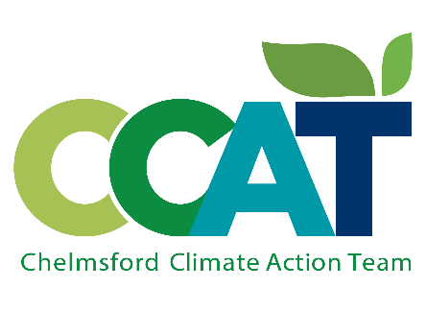

Fall 2022 Bulletin www.chelmsfordclimate.org

Meet us for a Chelmsford Climate Update on Nov. 14!
We are very excited to finally have permission to hold an in-person event at the Library. Come meet members of the Chelmsford Climate Action Team to hear an overview about the Climate Action Plan being developed by the town's Clean Energy and Sustainability Committee to address Chelmsford’s net-zero emissions goal. Following the presentation, we will have a brief Q&A and then an opportunity to meet and greet each other. Light refreshments will be offered. (Nov. 14, at 7 pm)
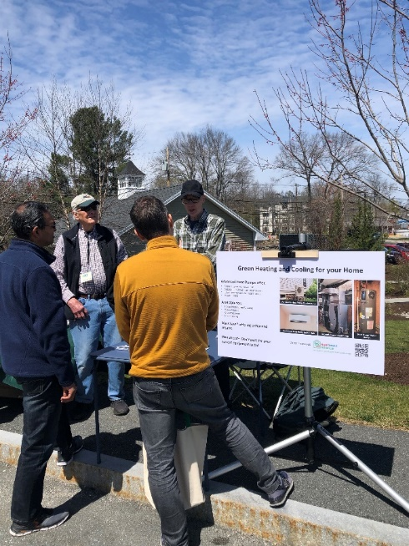
Earth Day Celebration on April 23rd at the Library
CCAT held our first environmental fair that included the town recycling committee and representatives from Heat Smart Alliance and Green Energy Consumers Alliance. We hope to make this an annual event.
CCAT in the 4th of July Parade
CCAT had a big presence at the Chelmsford July 4th parade with marchers holding banners, followed by a ride-on electric lawn mower*, three electric vehicles (a Chevy Bolt, Tesla and a Ford Mustang*), and most popular with the spectators – a family dressed as a walking wind turbine, Mother Earth, a recycle box, and a toddler dressed as the globe. The turbine merited a special commentary by the parade announcer as we passed by. Our group was interviewed by Chelmsford Telemedia at the McCarthy staging area, and we elicited cheers and clapping all along the parade route.

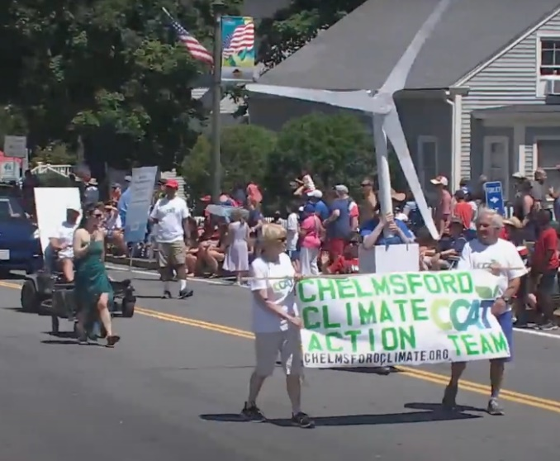

Chelmsford Farmer’s Market
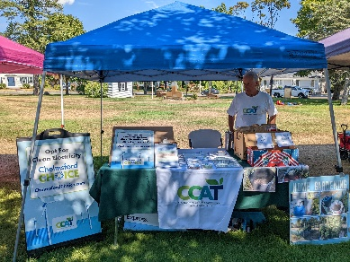
CCAT had booths at the Farmer’s Market on two Saturdays this summer, one in August and one in September. This gave us a chance to speak one-on-one with people about renewable energy options through the Chelmsford Choice Program. We were also at the 4-H Fair in Westford.

*courtesy of Clean Air Lawn Care Boston and McGovern Ford of Lowell

